SOFTWARE ENGINEERING

CLASS PRACTICALS

1.Airline reservation system (use case diagram)

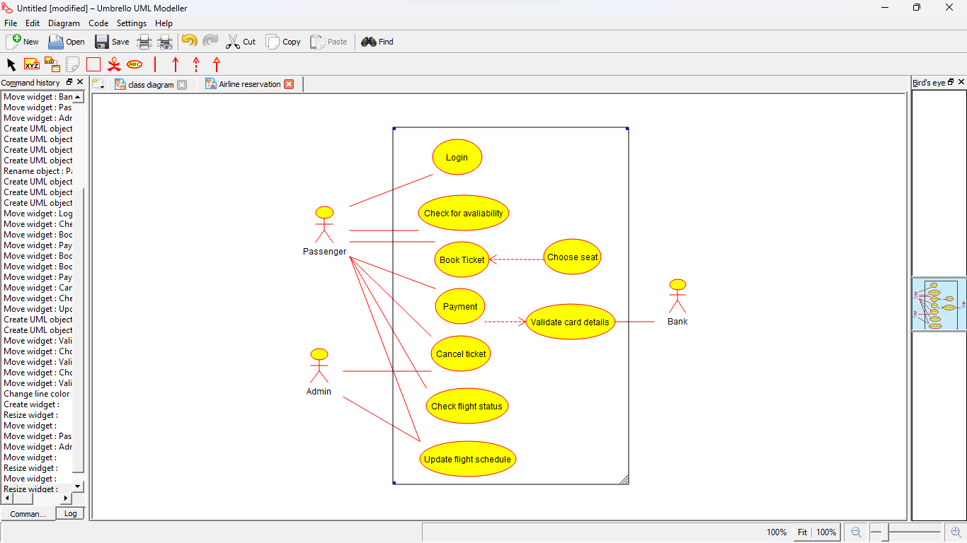

2.E-library system (Class Diagram)

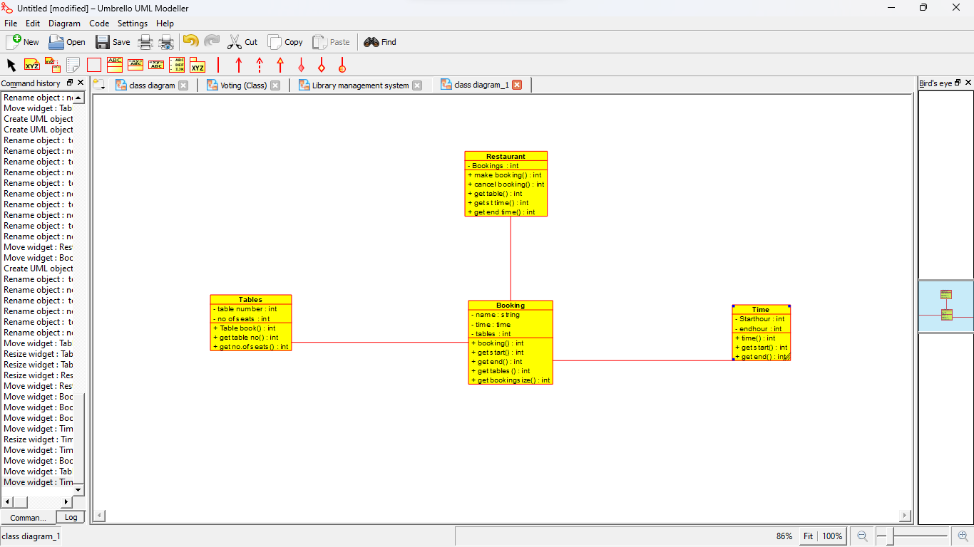

3.ATM Management system (Use case diagram

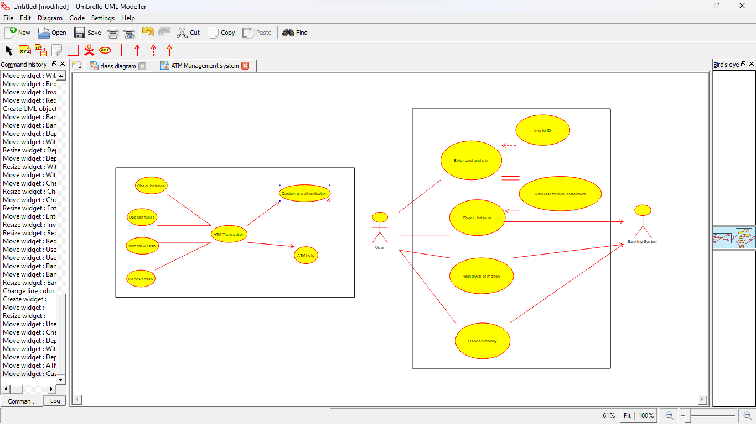

4.ATM Management system (Activity diagram)

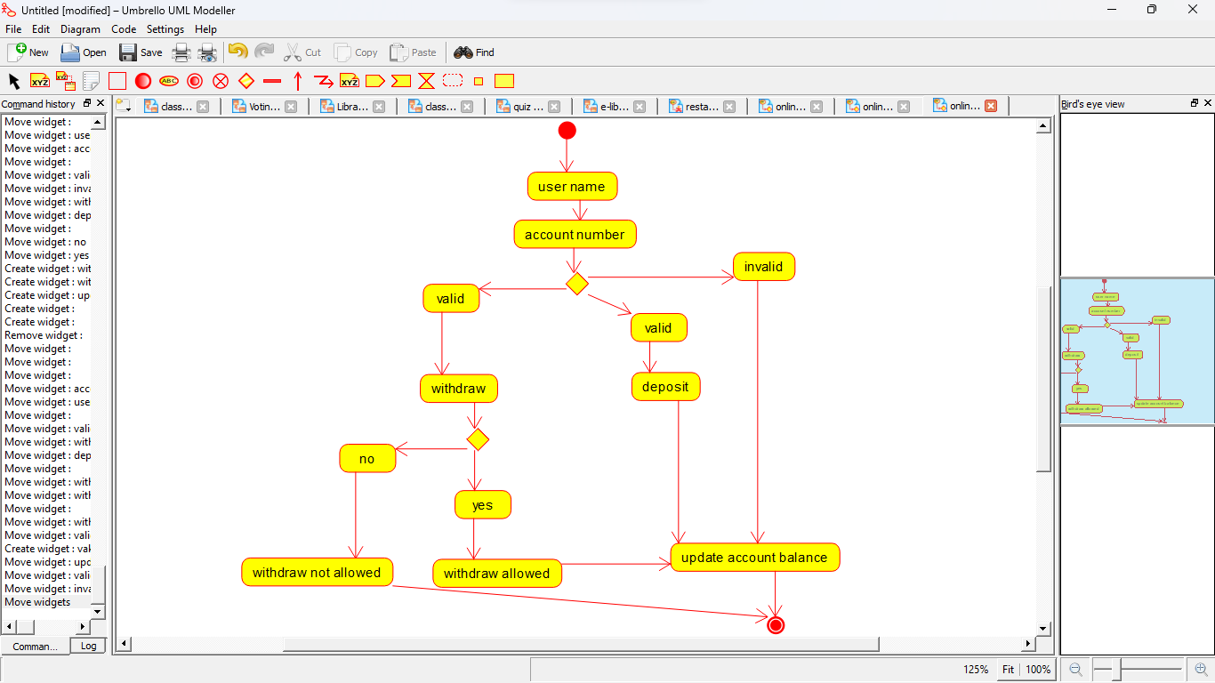

5.College management system (Use case diagram)

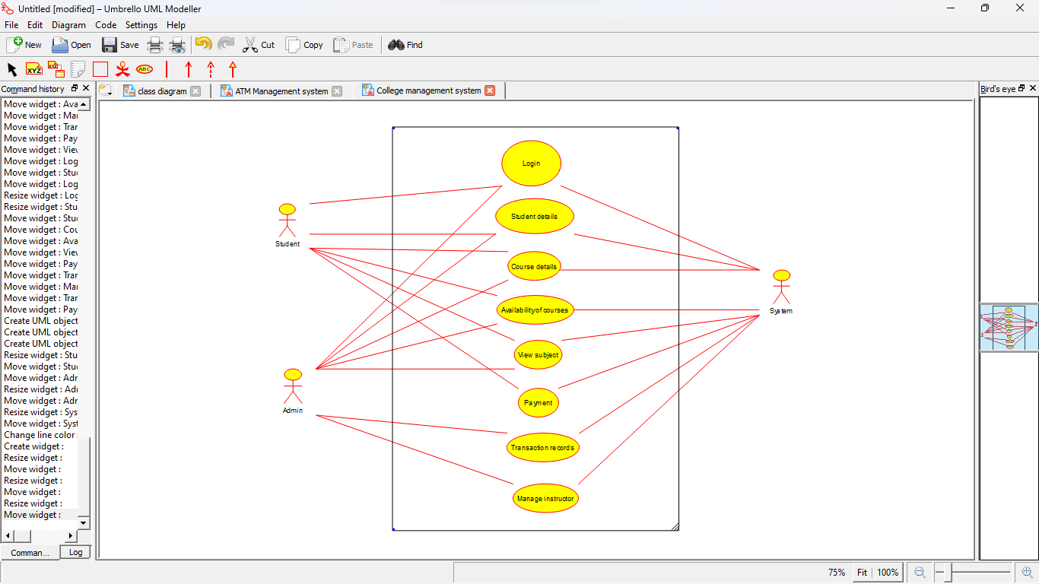

6.E-Library Management system (Activity diagram)

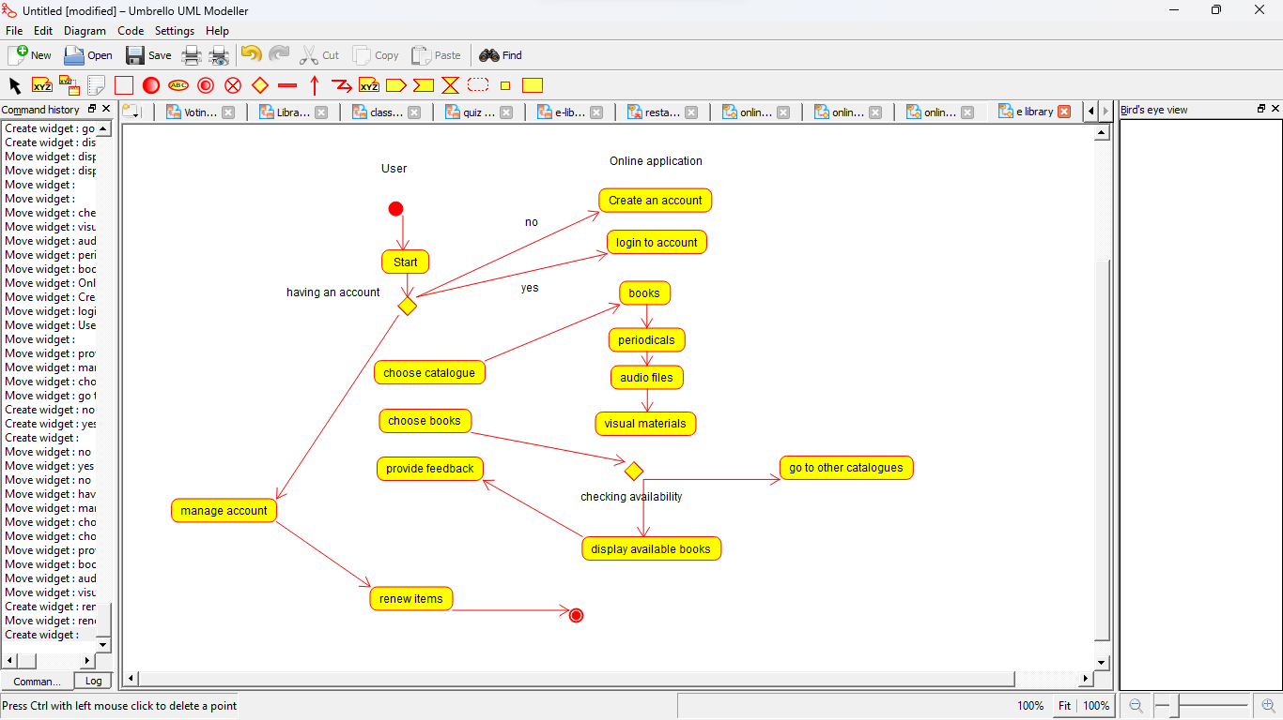

7.E-Library Management system(Class diagram)

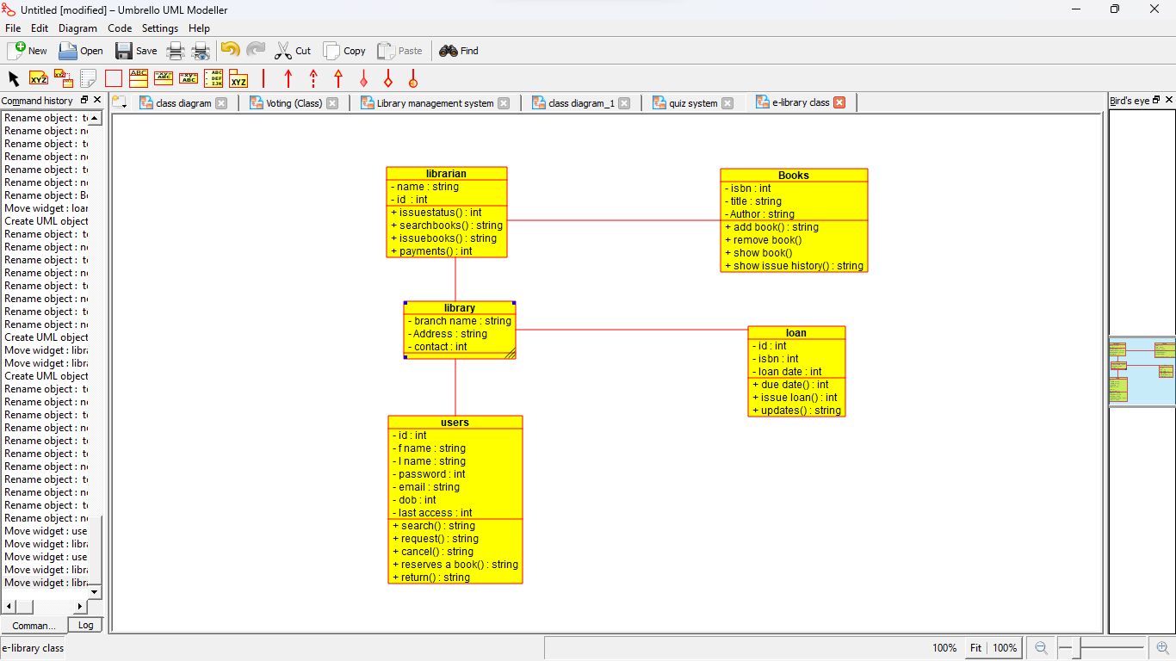

8.Online shopping management system (Activity diagram)

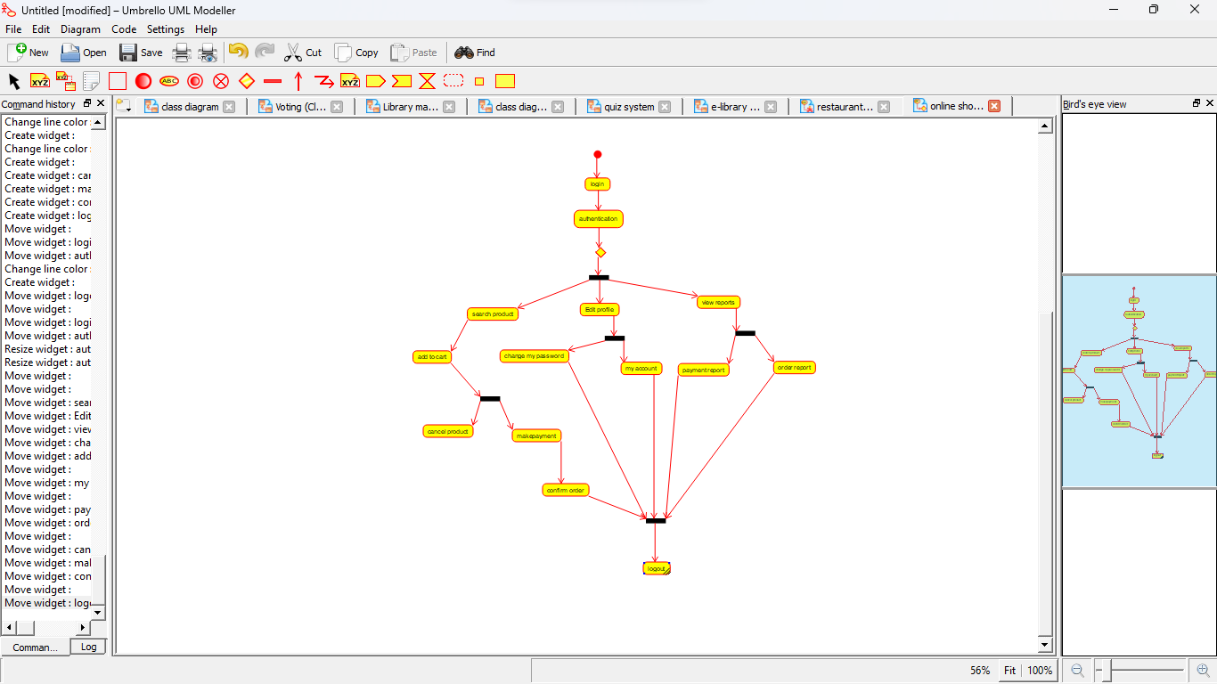

9.Quiz system (Class Diagram)

